Cassie Carrin CIT230

Site Plan | GAWeatherSite.com Site http://GAWeatherSite/content.com

GAWeatherSite.com $20/year

This site is going to be called A Weather Site. The two main purposes of this website are to educate the people of Georgia on local weather patterns and give a forecast of the current weather patterns being observed. It will show pictures of the patterns and the latest news from meteorologists about upcoming weather events.

The Target Audience:

The intended audience would be schooling or working Georgian teens and adults.

Who: Those who are currently around other people for most of the week, those who care about planning events, those who are working on something with their lives.

Age: Teens and adults 12+

Location: Georgia, USA

Scenarios:

1. What is the weather tomorrow?
2. What type of storm is coming?
3. What do these cloud formations mean?
4. What is the temperature going to be??
5. Will there be rain?
6. What happened with this month’s weather?

Site map:

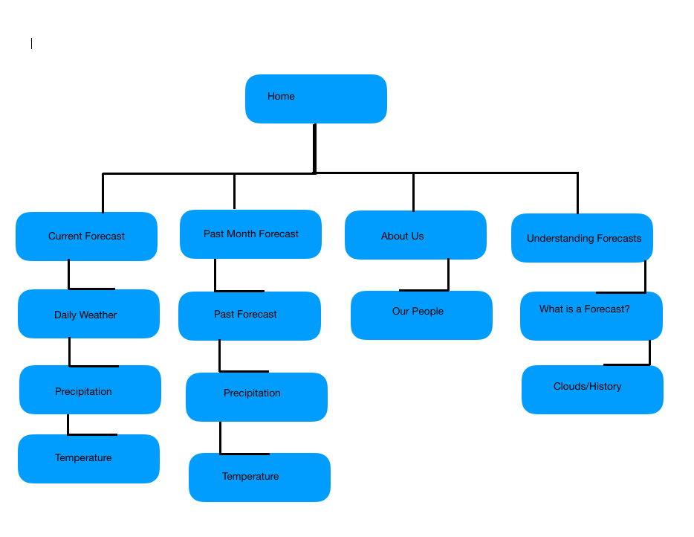

Typography:

The font will all be black with the exception of the site header, in which case it will be white.

